Chapter 19, Problem 71

Determine the z parameters for the network in Fig. 19.118.

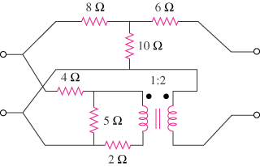

Figure 19.118
For Prob. 19.71.

